**#1.area of a rectangle with user input**

length=int(input())

breadth=int(input())

area=length*breadth

print("area:",+area)

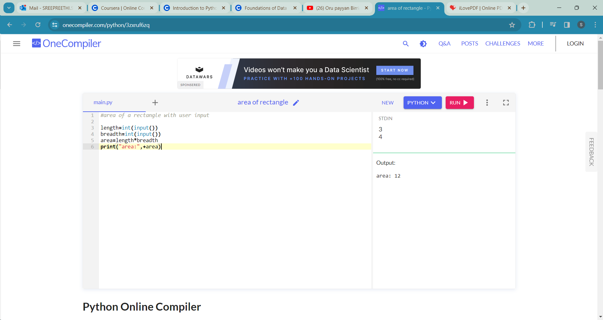

**#2.Create a program that takes a user's name and age as input and prints a greeting message**

name=input()

age=int(input())

greeting=input()

print(greeting ,name)

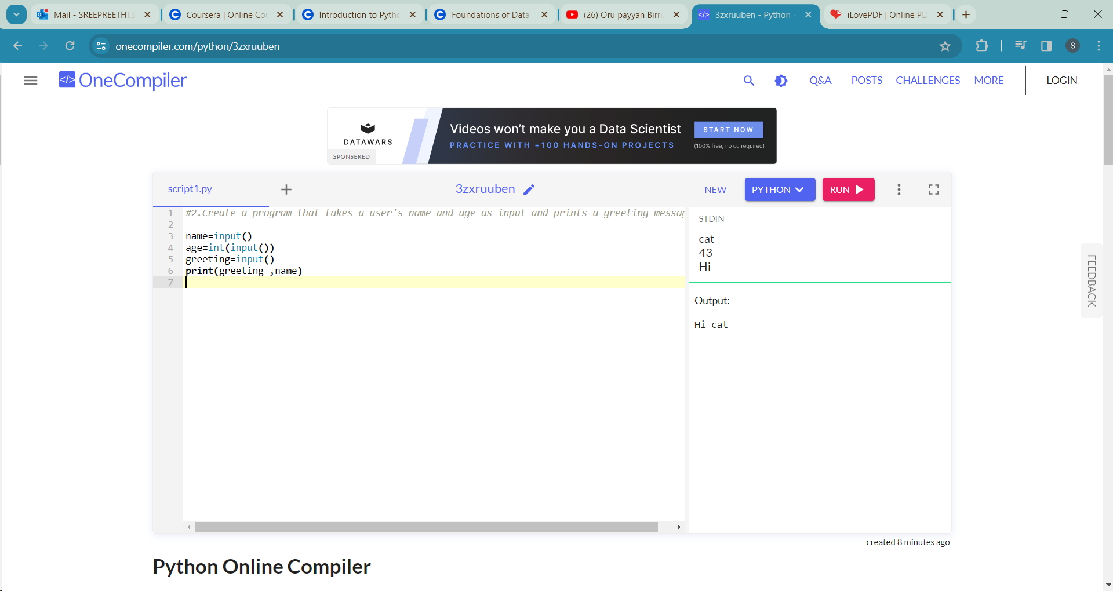

**#3.Write a program to check if a number is even or odd**

num=int(input())

if num%2==0:

print(num ,"is even")

else:

print(num ,"is odd")

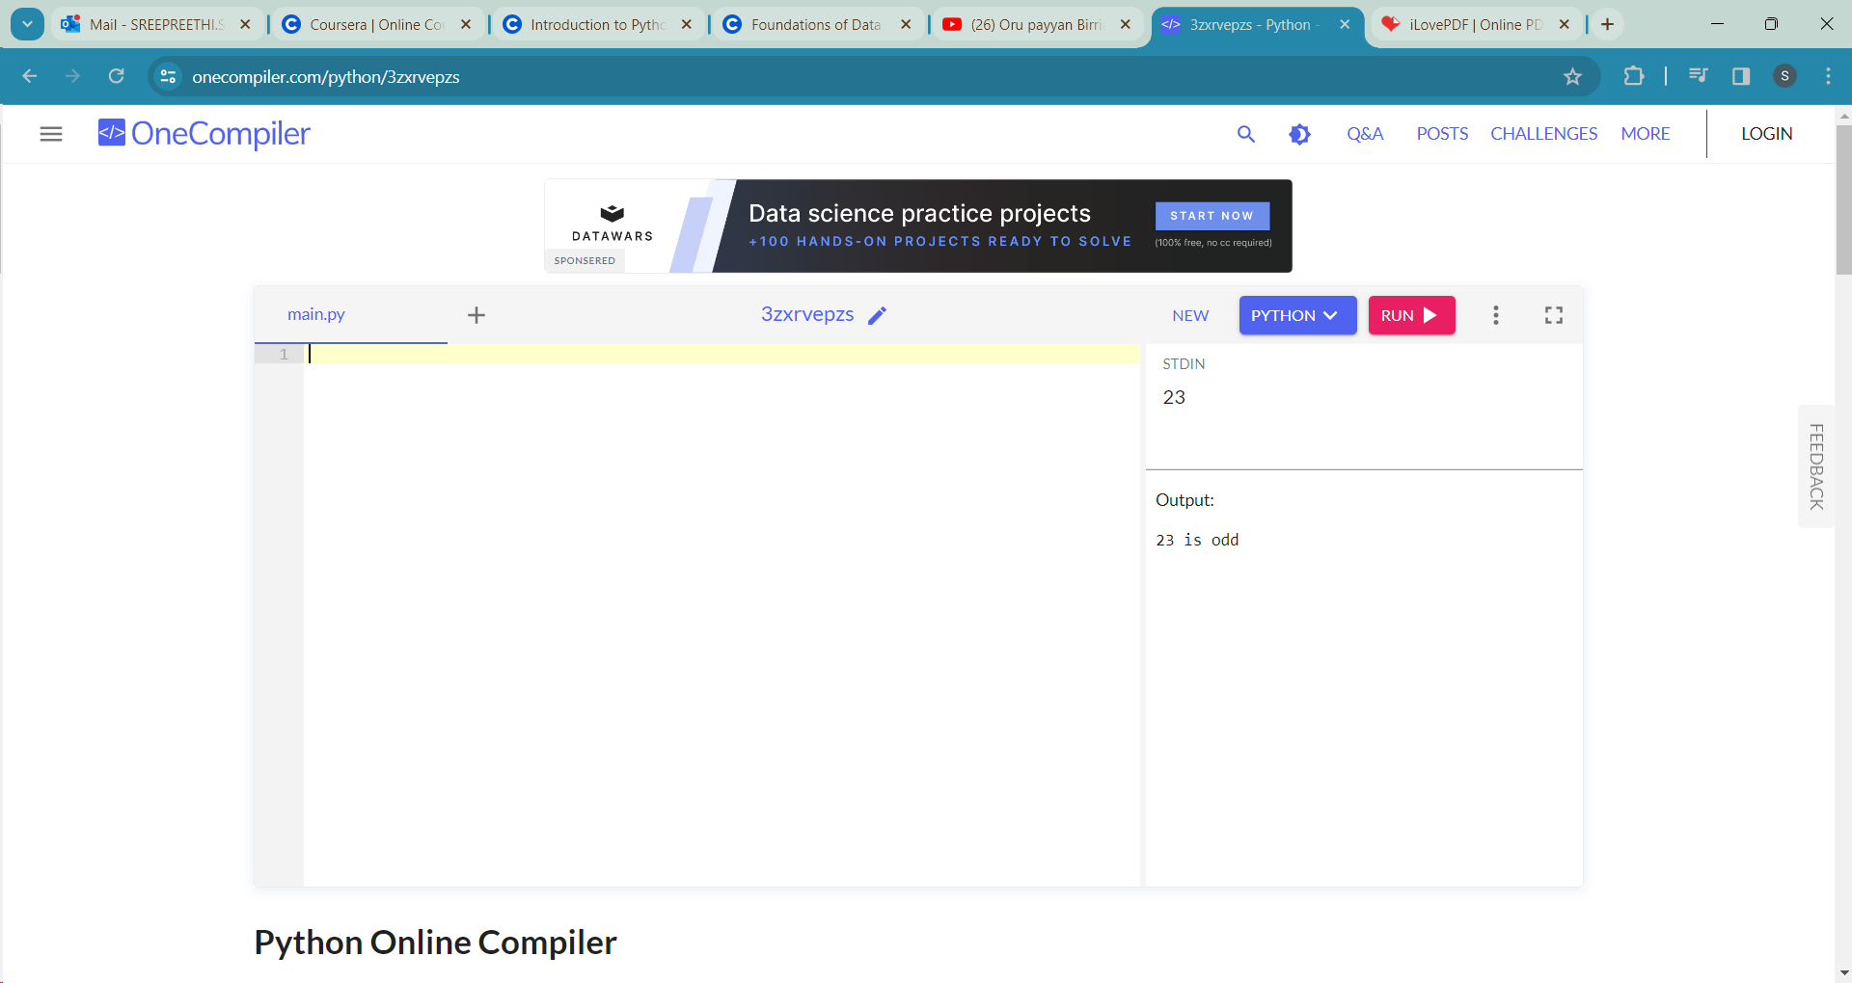

**#4.Given a list of numbers, find the maximum and minimum values**

element=input()

element_1=list(map(int,element.split()))

print("The max value is : ",max(element_1), ", The min value is :", min(element_1))

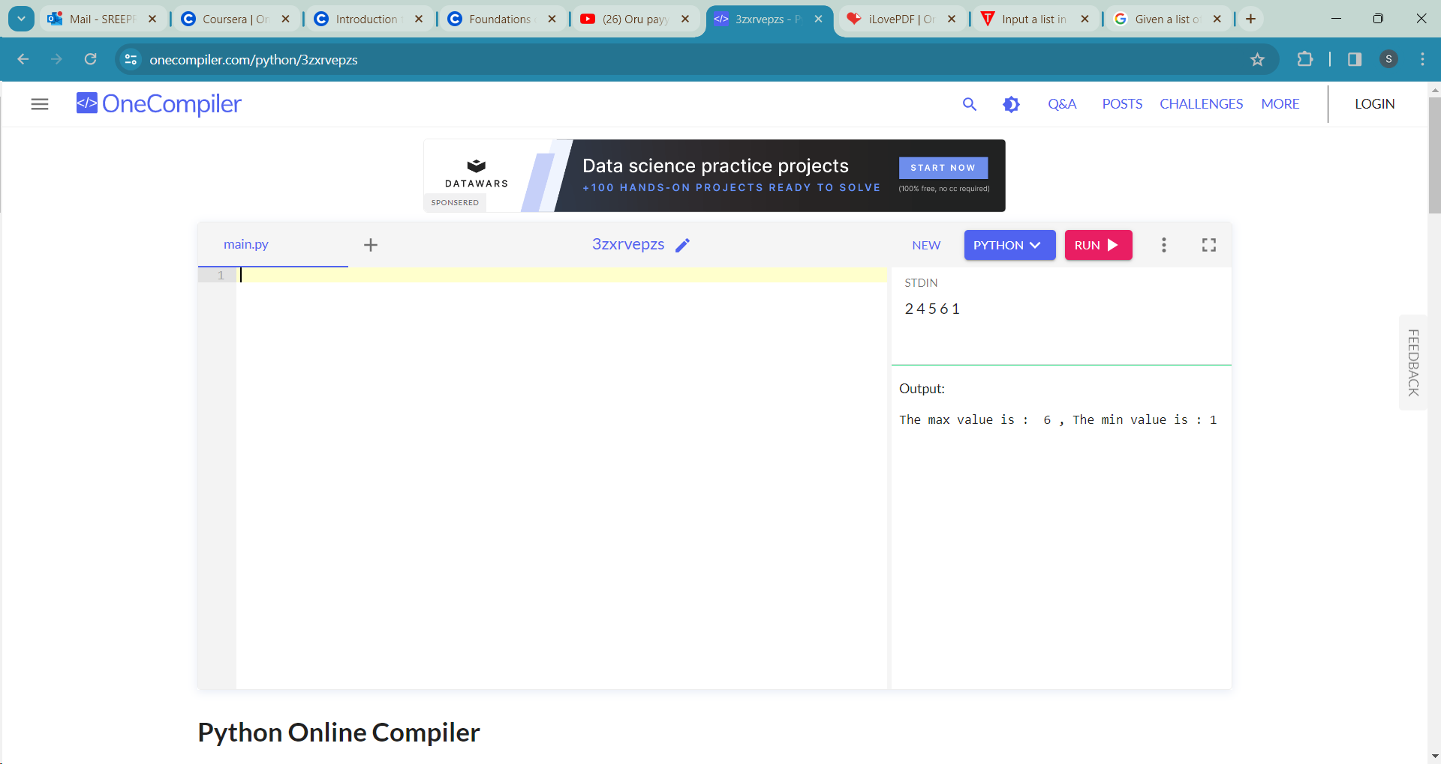

**#5.Create a Python function to check if a given string is a palindrome**

s1=str(input())

def is_palindrome(s1):

return s1==s1[::-1]

ans=is_palindrome(s1)

if ans:

print("yes")

else:

print("no")

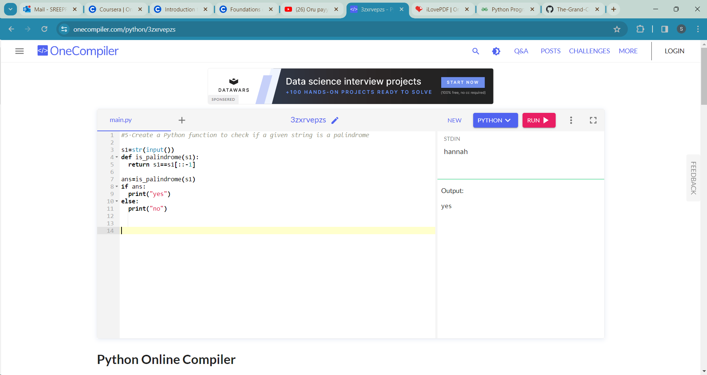

**#6.Calculate the compound interest for a given principal amount, interest rate, and time period**

"""

A=P(1+R/100)^t

A=amount

P=principal amount

R=rate of interest

t=time

CI=A-P

"""

p=int(input())

t=int(input())

r=float(input())

a=p*(1+(r/100))**t

print("Compound Interest: ",a-p)

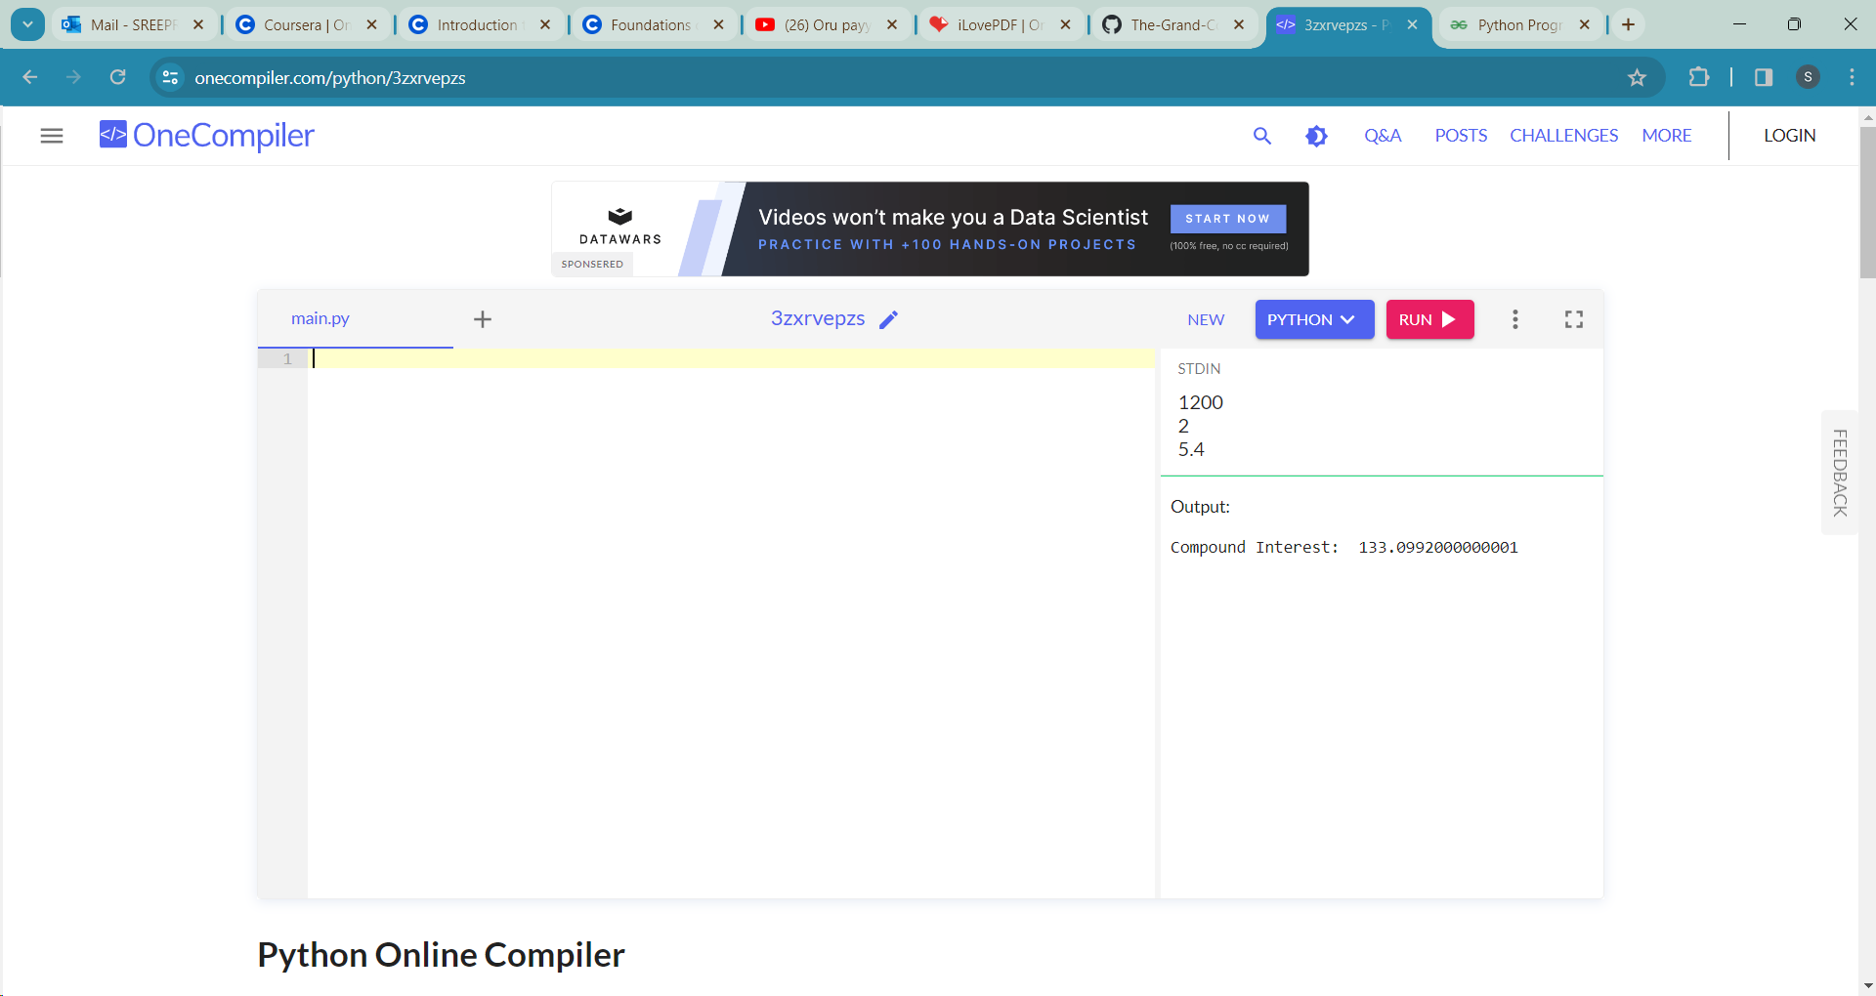

**#7.Write a program that converts a given number of days into years, weeks, and days**

num=int(input())

year=(num/365)

week=(num%365)/7

days=(num%365)%7

print("The days in week is: ",week)

print("The days in year is: ", year)

print("The days is: ",days)

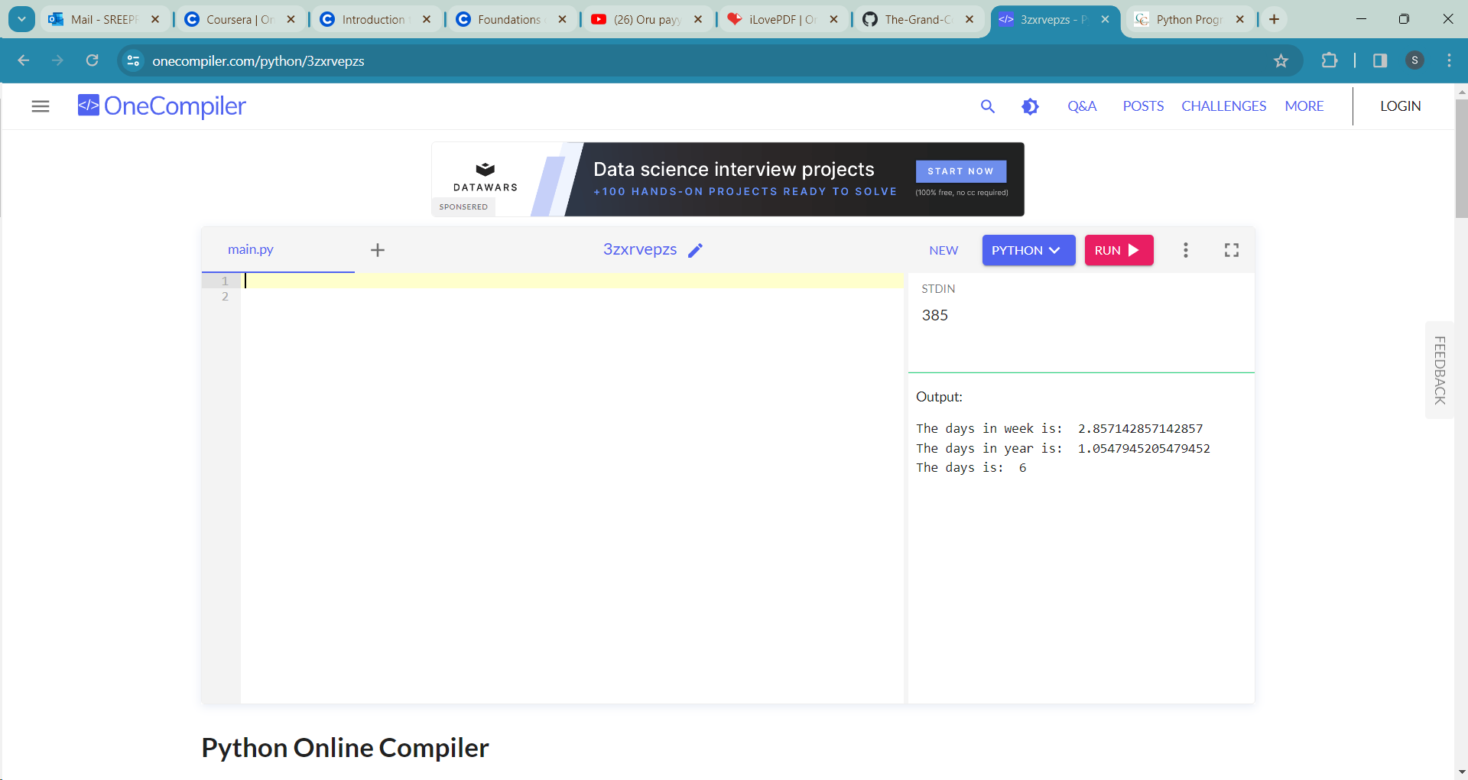

**#8.Create a program that takes a sentence as input and counts the number of words in it**

sample=input()

res=len(sample.split())

print("The count of words in the given sentence is:",res)

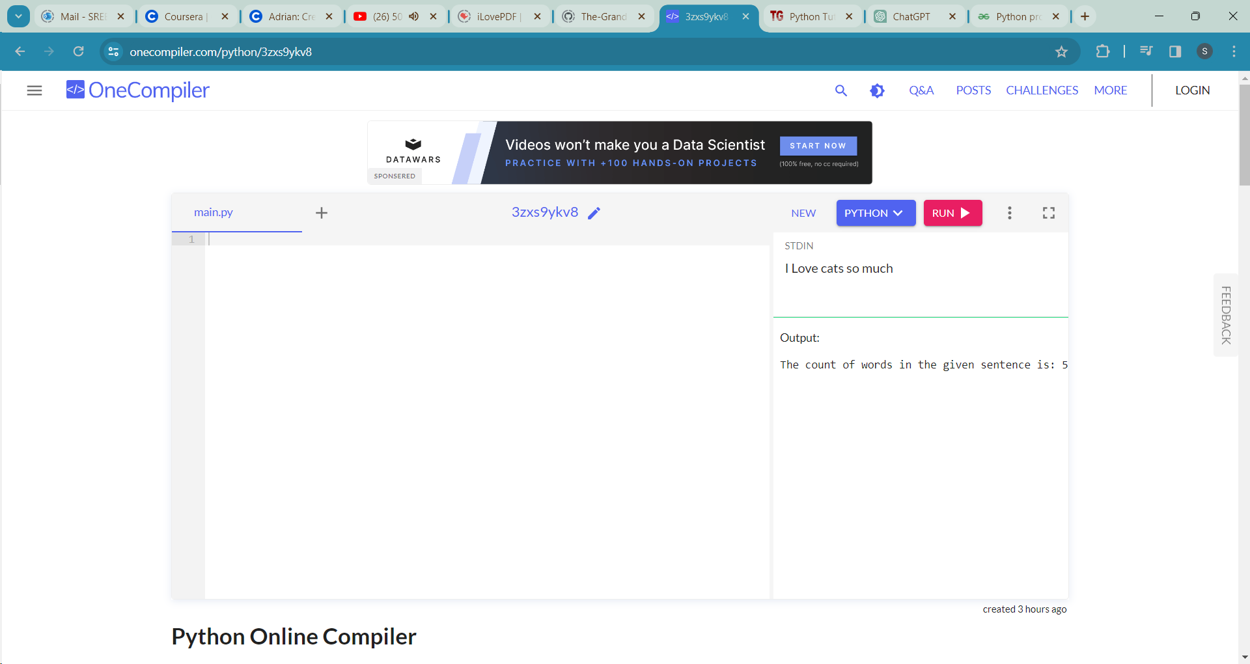

**#9.1.Implement a program that swaps the values of two variables.**

a=int(input())

b=int(input())

a,b=b,a

print(a)

print(b)

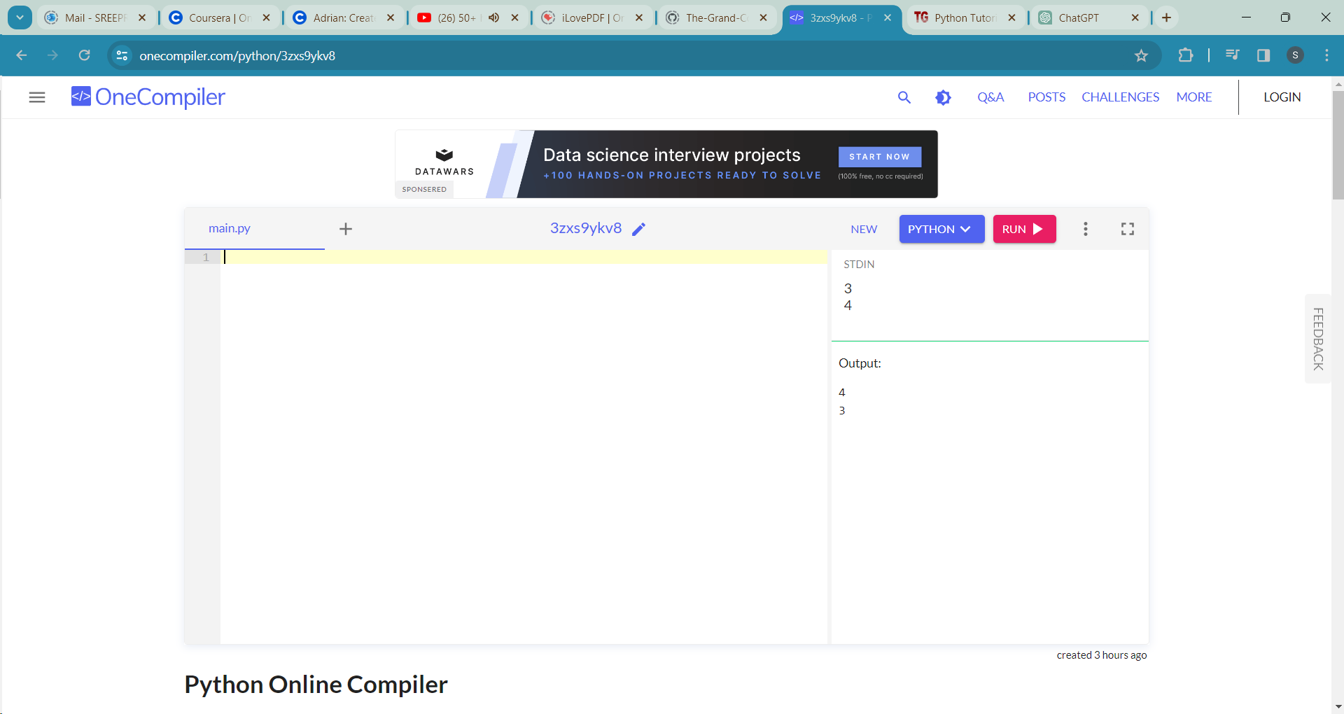

**#9.2.Implement a program that swaps the values of two variables.(with temp)**

a=int(input())

b=int(input())

temp=a

a=b

b=temp

print(a)

print(b)

